**Hackathons**

**ServerRipper** https://community.alteryx.com/t5/Alteryx-Server-Discussions/ServerRipper-Using-the-Alteryx-Gallery-API-to-download-workflows/td-p/561875

**Tableau Public**

https://public.tableau.com/app/profile/mark.tornga/viz/LungCancerSmoking-TC19-Aggregators_St_Louis_TP/Smoking

**Tableau Doctor - have seen many dashboards**

Justin Honold, Managing Director @ Ocelot Consulting if rebuilding D&A from scratch today, I would be amongst the first picked

Very complete end-to-end BI person

Proud:

Not what you said, not what you did, feel. Have a dozen more feedback like that.

Lasting impact

40 metric, 16 data source cyber metrics project

intv cloud people, DBAs, phishing, third party risk

Trust me w/ data, don’t want to be misrepresented

(onetrust, splunk, sharepoint, prisma, proofpoint)

pivot

Speaking at Tableau Day at client

PWC triple the price, inferior product

Luke switch, leadership, value focus

Can help with change: from microstrategy on oracle to Looker on bigquery , drew gillson

Tableau COE

180kTC would be 20% raise

**Difficult Decision:**

Luke Story

Alteryx galleries Vs. Studios vs. collections.

Researched, IAM, talked with users. Transparent with decision

400 active users running 1000+ workflows per day

**Tight Deadline:**

8 weeks to show value. Barely get a laptop and access.

Clear communication. Need access to experts. It’s your money

Focus on highest impact tasks and outcomes

**Conflict, Difficult**

Tim, had his own Tableau Server deployment

Listened, built trust, credentialized, trial balloon, no more adminning

Give and get

**Adapt to change**

I am the change. Have helped many ppl adapt. Yanan, spotfire

I adapted to change, ™ to OTM. Spine. Everyone pulled into solutions

Or exadata

Questions:  
Acquisitions / Integrations

Tech Stack

What are the key performance indicators (KPIs) that are most important to the finance department, and how are they monitored and reported on?

How do you as an exec use data in your work and decisionmaking

What other groups does this group interface with?

Can you tell me about the current team structure and the roles of the direct reports?

What are the team's strengths and areas for improvement?

What are the direct reports' individual goals and performance metrics?

Can you tell me about any challenges or issues that the direct reports have faced in the past, and how were they addressed?

How do you provide feedback to the direct reports, and what is your approach to performance management?

What kind of training or professional development opportunities are available to the direct reports?

Presentations

Administrating Through a Tableau Server Migration - Tableau User Group, December 2019

Modern Data Architecture: Batch vs. Streaming - Washington University in St. Louis, April 2019

Scaling Alteryx for the Enterprise - Alteryx Conference (Canceled)

Designing Effective Dashboards: Common Mistakes - Client, June 2020

Data Governance & Tableau Blueprint - Client, July 2020

Tableau 101: Designing Effective Dashboards - Client, July 2020

Feedback from the VP, CISO, and IT Leadership during our very first demo of the main dashboard -

"I think this is awesome"

"Impressive"

"I love this screen"

"Great dashboard screen"

"I could see this going in the board deck"

"The left scorecard, this is what it is." [reference to the Index scorecard mentioned above]

"Intuitive, drill down, can get to other tools"

"I’m blown away"

"Love the landing page"

"I think it’s a great view"

"This is really impressive"

During a moment of happiness as I watched us successfully finish the last leg of a 5 day (one month?) Data Week at Charter, I wrote this in the office alliances channel on Slack:

[@Lindsay](https://slalomstl.slack.com/team/UAPEHP22X) I want to point out that Tableau did us a favor. We needed content for our final day of Data & Analytics week. Phil D'Amico had given a presentation to us, slalom. We asked Tableau if he could turn around and provide the same presentation for our client. His normal scope of work is to work with partners, not our clients. Without any red tape, resistance, explanation or context, he agreed to do it. This is a product of the partner relationship that [@Lindsay](https://slalomstl.slack.com/team/UAPEHP22X) and others have maintained.

I'll expand on that here. We kind of agreed to Tableau's plan to put on a Data & Analytics week for our common client, Charter. The plan was a grand one: 7 sessions, 5 straight days, < 20 working days to line everything up and get the logistics right.

During a moment of happiness as I watched us successfully finish the last leg of a 5 day (one month?) Data Week at Charter, I wrote this in the office alliances channel on Slack:

[*@Lindsay*](https://slalomstl.slack.com/team/UAPEHP22X) *I want to point out that Tableau did us a favor. We needed content for our final day of Data & Analytics week. Phil D'Amico had given a presentation to us, slalom. We asked Tableau if he could turn around and provide the same presentation for our client. His normal scope of work is to work with partners, not our clients. Without any red tape, resistance, explanation or context, he agreed to do it. This is a product of the partner relationship that* [*@Lindsay*](https://slalomstl.slack.com/team/UAPEHP22X) *and others have maintained.*

I'll expand on that here. We kind of agreed to Tableau's plan to put on a Data & Analytics week for our common client, Charter. The plan was a grand one: 7 sessions, 5 straight days, < 20 working days to line everything up and get the logistics right. My first call after agreeing to this was to Lindsay. I figured she would have the experience and connections to help us pull it off.

I was glad I did. Tableau and Charter threw plenty of surprises at us. The client bucked about who had been invited and how that upset their internal politics. Tableau did their best to upset everything with bad ideas and poor timing. Lindsay was like the captain of the ship piloting us safely through the storm and into port. I appreciate immensely the number of calls and texts she sent to our Tableau partner and to Big Slalom to keep this all on track.

It boggles my mind that dealing with our Data Week was not her full-time job during July and that she had other partners and projects to deal with at the same time.

INTRO

Intro

D&A for about 8 years, with nearly 4 in consulting and previously as a manager of a business intelligence org in the transportation space.

BI to me is about finding the data where it lives and using it to drive an action or to tell a story that will create business value. Sometimes we call it data viz or data engineering but its an end to end process with the tip of that iceberg being the dashboard or the KPIs or the report.

The large chunks of my experience fall into about two major categories - so as a developer being that data wrangler that pioneers new data pipelines - client might say oh we've never been able to incorportate our Solar Winds or AppDynamics data into our analytics but now we can.

And the other chunk being what I call analytics enablement. Building up Tableau Server, Alteryx Server at an enterprise scale and doing trainings, webinars, centers of excellence to build more of a data culture that will grow

FEEDBACK

​​**Delivery Exceptionally** is still my main focus so we will start there.

*Guides team members and customers to meet and exceed delivery commitments*

After bringing in a more junior consultant to take the reigns it was important that I helped her understand what we were committed to, the nature of the work, the nature of our clients and stakeholders, and what it would take for her to continue delivering exceptionally. With my parental leave looming, I kept Alya focused on the top project priorities by leading our daily stand-up, creating user stories, assigning stories, and grooming our backlog. I prompted her every morning with the question "what would Alya do if Mark's baby came today?" By maintaining this sense of urgency we accelerated the process of having Alya fully internalize the direction of the project and take the lead.

*Builds support for ideas and enrolls others / Weighs several solutions to determine “best fit” / Delivers high-quality written, verbal and/or visual communications*

In our metrics project we had a few executives with ideas of where they wanted the dashboard to go directionally but without concrete ideas about how it would work. Specifically, the metric index which would be a summarization of the various metric results. This can be a fraught concept in Business Intelligence because it abstracts the results into something "simplified". If the method of summarization is confusing or misleading, then the users will not trust the index and you'll be left with nothing. The user wants an oxymoron - a summary where they can understand the details. How to accomplish this was not clear - after an initial brainstorming session with VP Erica and CISO Chris, Chris's parting advice on how to proceed was "good luck."

I decided on a simple and transparent weighted average, nothing groundbreaking, but presented it in two visuals: One with the summary index score shown for each NIST Subcategory, and one visual dubbed the Brick Wall showing how the individual bricks add up to the index score. The whole dashboard page was dedicated to helping the user understand how the sausage was made. From this solid ground I defended against various bad ideas. For example, they asked for the index to be rolled up to a higher level than subcategory - to Category or higher to Function. I was able to use my visuals to show how we did not have enough coverage at those two levels to create a summarization - the summary or index at those levels would be misleading.

*Delivers high-quality written, verbal and/or visual communications*

Feedback from the VP, CISO, and IT Leadership during our very first demo of the main dashboard -

"I think this is awesome"

"Impressive"

"I love this screen"

"Great dashboard screen"

"I could see this going in the board deck"

"The left score card, this is what it is." [reference to the Index scorecard mentioned above]

"Intuitive, drill down, can get to other tools"

"I’m blown away"

"Love the landing page"

"I think it’s a great view"

"This is really impressive"

This feedback comes after months of tensions about "what is the dashboard, and where is it?" from our team and their team. The project "cybersecurity dashboard" started in August and the big demo didn't happen until late January. I am proud of myself for resisting the pressure to deliver something empty, incomplete, just a guess at what the dashboard should be in November or December. My experience in this industry told me that I needed more alignment, more content, more understanding of the REAL client needs before anything could be presented as "the real dashboard". I did deliver smaller dashboards along the way with the caveat that they were not "the real dashboard." After months of marinating, the dashboard was produced in about a week. This was possible because we had attained real understanding of what they needed.

The alternative to this approach would be building incomplete rough drafts and presenting those for feedback and guidance. With our high profile stakeholders, they would have ripped those up, been suspicious of our understanding and ability, and it would have brought on negativity, pressure, and scrutiny. Executives peek in on a dozen projects per week and for that reason they must make judgements quickly. They don't have the time or attention to follow the progress of a dashboard over weeks or months. You generally get one shot at making a positive impression. They're going to categorize your project as either "going well, no intervention needed" or "project is tanking, intervene and/or start pointing fingers".

• For a major telecommunications company, assessed the health and contents of a Hadoop data lake. Inventoried all HDFS and Hive objects using a combination of native Hadoop capabilities and Bash CLI scripting. Surveyed or interviewed over 100 data owners to understand what the data meant and how it was being used. Recommended improvements in how to configure the Hadoop cluster to increase performance and efficiency.

Here are some highlights:

Presentations

Administrating Through a Tableau Server Migration - Tableau User Group, December 2019

Modern Data Architecture: Batch vs. Streaming - Washington University in St. Louis, April 2019

Scaling Alteryx for the Enterprise - Alteryx Conference (Canceled)

Designing Effective Dashboards: Common Mistakes - Client, June 2020

Data Governance & Tableau Blueprint - Client, July 2020

Tableau 101: Designing Effective Dashboards - Client, July 2020

Client Engagements

• For a major telecommunications company, built out a highly available Tableau enterprise environment, lower environments, and an accompanying Center of Excellence. I worked with developers, admins, and stakeholders from multiple independent servers to coordinate a migration to the new enterprise Tableau environment. The impact has been incredible to witness, with 8,000 active users

Tech used sorted by importance, descending: Windows Server Administration. SQL, Postgres, Alteryx Designer.

• For a major telecommunications company, conducted a major upgrade of a multi-node Tableau Server cluster from version 10.3 to version 2018.3. Trained admins and developers on the changeover from .tde to .hyper format as well as the change from tabadmin to tsm. Bash script for automating backup and cleanup. SQL, Postgres, alteryx.

• For a major telecommunications company, built out a multi-node Alteryx Server cluster. Windows Server Administration. MongoDB.

• For a global financial company, Data as a Service. R, Nginx, Apache HTTP Server, Swagger, Node.js, APIs, Postman, Looker, Nifi, BI architecture, Data Engineering. SQL, Power BI

• For a major telecommunications company, conducted an analysis of their direct sales and web sales channels for both sales performance and application performance. Tableau Desktop, Tableau Server, Alteryx Designer, Alteryx Server, AppDynamics, Splunk, SolarWinds, SQLite. Agile. SQL.

• For a regional utility in a two-week engagement, aided in an upgrade of an enterprise-wide Tableau Server from version 10.3 to version 2018.3. Training, demonstration of new features, server monitoring.

• For a major telecommunications company,

Over an eight week engagement, Slalom partnered with Data Management as they launched their first-ever instance of Podium on a Hadoop cluster.

Slalom launched the first data source to production while setting the path for two more. Using SFTP, Podium, a dash of Bash scripting, PGP encryption, HDFS, Hive, and Automic ONE Automation, the team landed the first data source in a secure, web-based location that will provide users with a single source of the truth.

The Sales Science team at a top five telecommunication company had been struggling for years against labor-intensive data manipulation and the use of ill-equipped tools. They were relying on a combination of Microsoft Access, Excel, and other tools, none of which is designed to address the volume of data required for accurate, real-time business reporting and analytics.

As a bonus, Sales Science stood to save $2.1 million per year if they could bring their five data sources together into a centralized, secure, and web-based database.

Congratulations, Mark! You’ve been recognized as a 2020 Slalom-Tableau Rockstar!

You have been a shining star for our partnership this year. We are recognizing you for your commitment and passion for Tableau.

You and your fellow Rockstars have gone above and beyond by building innovative dashboards and solutions, providing exceptional service for our customers and helping our customers address the unique challenges of COVID.

Here are sample excerpts from your nomination:

*“Mark has been one of our Tableau champions on the platform side. He is one of the deepest in Tableau Server and it able to help lead our clients in building world-class sustainable platforms that enable entire businesses. He is quick to raise his hand and jump into a new client problem whether how best to move their deployment to the cloud or create a low-effort solution for server management.”*

*“This July, Slalom executed a weeklong analytics webinar for one of the leading companies in STL and all of Slalom. Originally the webinar attendance goal was approximately 50, however, over 420 unique individuals (and 350 each day minimum) attended. Mark led this endeavor in tight partnership with the client and Tableau. As a result of these efforts, demand for analytics and data visualization using Tableau is growing exponentially, there is cost extensive cost saving and the client is beginning to get more value from its data. ​​ Additionally, the Slalom STL partner leader was recognized by Tableau for their “One Million Conversations” – which would not be possible without this activity. Mark serves as Slalom STL's Partner Champion for Tableau and is an incredible leader- we're lucky to have him!”*

Jeff Rummel

Rebecca Ernst

To steal from Steven Quinn’s words, Mark is a “true professional”, which to me means that he is responsible, a self-starter, and an expert in his field. During the BI Rationalization project at Equifax, he was able to flex in training facilitation, dashboard rebuild, and he made an impact with the Tableau Admin group. He is calm and confident when asked questions and presents material naturally and with ease. His ability to answer questions made him a favorite of a few of our most inquisitive client employees. He is a great team member and is always willing to help someone else when they run into challenges in Tableau design. I am going to miss the humor and intellect that he brought to our team.

My work with Tableau, Alteryx, and Looker to stand up on-prem (or "customer managed" in Looker terms) and cloud instances of these platforms has given me tons of Platform experience. The Windows Administration and Linux skills needed to manage multi-node, multi-app clusters is rare and hard-won when coming from the Data Viz / Data Prep world. I used and developed tools for platform health monitoring, performance management, event alerting, firewall/networking management, SSL cert management, and VERY importantly - infrastructure automation. Charter, Mastercard, Equifax, Spire.

"Has driven complex design, configuration, and analytics solutions without significant help from a Solution architect on a large, medium complexity project - 1) Led design, configuration, and rollout of enterprise Alteryx Server platform at Charter. This was an enormous effort as it entailed working across several IT groups at Charter to size and procure hardware, configure networks and security, and enable access to data sources. The build-out entailed setting up three separate environments (DEV/UAT/PROD), each of which was configured to enable multi-tenancy and consisted of multiple clusters of machines each performing different jobs. In the case of UAT and PROD, each platform consisted of 4 Worker nodes, 2 Gallery (web server) nodes behind a load balancer, 3 controller nodes configured for Windows Failover Clustering (high availability), and a 3-member MongoDB replica set for persistence. According to Alteryx, each of these environments represented one of the largest customer implementations of Alteryx Server in the world. Throughout the engagement, complex troubleshooting was required both on the server side as well as for front-end users of the platform. When we left Charter, the platform was supporting 250+ production users and was capable of taking on at least 750 more given its sizing. The work we did also incorporated infrastructure automation using Ansible and significant automation of the maintenance and administration processes through Powershell. In leading this work, I worked with a team of two other Slalom D&A consultants (Mark Tornga, Mike Champlin) as well as a team of 4 Charter administrators over the course of a year. Along the way we performed numerous maintenance upgrades. This work was executed as part of multiple SOWs/extensions that resulted from client satisfaction with our delivery that consistently hit scope, schedule, and budget.

My work with Tableau, Alteryx, and Looker to stand up on-prem (or "customer managed" in Looker terms) and cloud instances of these platforms has given me tons of Platform experience. The Windows Administration and Linux skills needed to manage multi-node, multi-app clusters is rare and hard-won when coming from the Data Viz / Data Prep world. I used and developed tools for platform health monitoring, performance management, event alerting, firewall/networking management, SSL cert management, and VERY importantly - infrastructure automation. Charter, Mastercard, Equifax, Spire.

Charter -

I worked on many SOWs over a two year period on the Tableau Server consolidation and upgrade. We combined two major and a few minor Tableau Server implementations into one enterprise-wide environment. One major legacy server had 36 sites and 160,000 views per week. The other had 19 sites and 60,000 views per week. The new environment consisted of a four-node PROD cluster, four-node UAT cluster, and four-node DEV cluster. The represents a large step up in complexity from the single-node clusters that existed previously at Charter. Drivers and network connections had to be configured for about 100 different data sources. The environment had to be tuned for the specific usage patterns at Charter by increasing or decreasing Backgrounder, VizQL, and Cache Server processes. I configured for high availability by setting a cluster coordination service between the nodes. We scripted daily backups. I presented about this migration to a multi-node enterprise environment at STL Tableau User Group in December of 2019. We worked with Tableau technical managers who evaluated the environment and they found it to be sound. I have done detailed capacity planning for Charter, explaining how to measure usage and impact on their environment, how to scale and why, and where their bottlenecks will be. Much of this is based on whitepapers published by Tableau engineers.

Based on the solid work done on Tableau, the stakeholder Andy asked Slalom to recommend a data prep product that could also be provided to the enterprise like Tableau. I did a comparison of Tableau Prep and Alteryx Server and ultimately recommended Alteryx Server.

I plotted three phases of architecture for the next year. This included detailed node configuration and a calculation for the chargeback to users that would allow ITDM to bring in an acceptable amount of offsetting funds. I did the initial install of the two-node PROD and UAT clusters and then left for Mastercard. When I returned, Mike Champlin and Jon Marshall were on the cusp of installing the hardware and software for the phase 2 and 3 architectures.

As Jon puts it - "This was an enormous effort as it entailed working across several IT groups at Charter to size and procure hardware, configure networks and security, and enable access to data sources. The build-out entailed setting up three separate environments (DEV/UAT/PROD), each of which was configured to enable multi-tenancy and consisted of multiple clusters of machines each performing different jobs. In the case of UAT and PROD, each platform consisted of 4 Worker nodes, 2 Gallery (web server) nodes behind a load balancer, 3 controller nodes configured for Windows Failover Clustering (high availability), and a 3-member MongoDB replica set for persistence. According to Alteryx, each of these environments represented one of the largest customer implementations of Alteryx Server in the world. Throughout the engagement, complex troubleshooting was required both on the server side as well as for front-end users of the platform. When we left Charter, the platform was supporting 250+ production users and was capable of taking on at least 750 more given its sizing. The work we did also incorporated infrastructure automation using Ansible and significant automation of the maintenance and administration processes through Powershell. In leading this work, I worked with a team of two other Slalom D&A consultants (Mark Tornga, Mike Champlin) as well as a team of 4 Charter administrators over the course of a year. Along the way we performed numerous maintenance upgrades. This work was executed as part of multiple SOWs/extensions that resulted from client satisfaction with our delivery that consistently hit scope, schedule, and budget."

I was very involved in building and rebuilding nodes, complex troubleshooting, the Windows Failover cluster, and bringing Ansible automation into the mix. I was on the submission for the Analyticon presentation (Alteryx conference) which was accepted by Alteryx. Unfortunately it has been delayed.

Mastercard -

I was the more technical resource on the Data as a Service platform. We built a platform from a few pieces. We used Looker as a query-building engine, Nifi for authentication and data egress, and a custom JS front end. I went very deep into each of these elements. I had a feature suggestion for Looker that made it into a release during the project.

Cigna -

I did 24 hours of Alteryx Enablement Hours through Alteryx for Cigna. During that engagement I worked with a few platform admins from Looker and Business Objects and taught them to apply their skills to Alteryx Server.

Spire -

I worked with two admins to upgrade their Tableau environment from 10.2 to 2018.3 and work on Server best practices.

In summation, I feel very confident architecting and administrating these platforms. These skills are not specific to one platform or even one OS. I have used Windows and Linux both on-prem and in the cloud. We talked about doing platform work for SAS at Charter. I have never used the tool SAS but I have complete confidence that I could work competently on the platform.

:alert: ME @ SLALOM last minute guidance :siren:

Consider **Platform Technical Architect** as an active or aspirational role on your Me@Slalom.

Our market received guidance from Hilary Feier of m@s fame that the **Platform** roles should NOT be interpreted as only applying to Salesforce.

Some experiences from our market that I'm aware of that apply to this role:

Tableau Server implementation and administration

Alteryx Server implementation and administration

Roll-your-own platforms like DaaS (Looker / Nifi / JavaScript frontend)

If you find that you are...

Admin on an app that hosts hundreds or thousands of users

Doing application performance management (APM)

Forecasting capacity of an enterprise-wide application

Hosting apps on Windows/Linux servers on-prem and in the cloud

Designing and implementing Authentication and Authorization schemes

Fussing about SSL certificates

Elbow-deep in the logs

... Then consider the role

Per m@s:

"A Platform Technical Architect is responsible for setting the overall direction of the technical solution of the implementation with an enterprise application. A Platform Technical Architect has a breadth of technical knowledge and experience with an in-depth knowledge of their specialist enterprise application"

Experiences

**Has led data visualization approach for projects, designs data viz instructional content and trains clients and other consultants**

--Equifax, Charter - Designed Tableau dashboard template used across the org. Delivered many Tableau trainings in 1:1, small group, workshop, and webinar settings. Trained Tableau server admins as well.

--Charter - Trained users and admins on Alteryx Designer and Server.

--Spire - In a two-week engagement trained Tableau server admins and many business unit groups of Desktop users.

--Mastercard - Trained Mastercard and Slalom folks in the use of Looker. Left training videos behind.

--Internal - Presented Tableau Partner Day wherein I trained folks on new Tableau products. JJ Jasper assisted. Trained Steven Hopper in multiple 1:1 sessions

--Cigna - 24 hours

**Has gained deep expertise in data storytelling and information design (design thinking, semantically resonant colors, Gestalt principles)**

Yes

**Has recognized and advised on where to improve performance upstream of viz tool**

Yes I have tuned Alteryx workflows, Tableau workbooks, have made Tableau Server settings and topology changes for speed, tuned SQL queries, and advised on database changes to improve speed.

**Has advised client on data viz development best practices, self-service analytics models, data viz security and governance**

I have delivered the webinar *Designing Effective Dashboards* three times this year on this topic. Have advised clients on row-level security and permission structures in Tableau, Alteryx, and Looker.

**Has made data model/architecture recommendations for optimal data visualization performance and use**

Yes. Have advised on data prep including Tableau Prep, Alteryx, and R. Have advised on Tableau extract use and Looker persistent derived table use. Also data replication and data source selection.

**Has delivered solutions with Row-Level or complex database security**

Mastercard - custom auth scheme for Looker.

**Has advanced data prep expertise (i.e., designs data prep instructional content) and trains clients and other consultants**

Alteryx - Charter, Cigna

**Has advised on performance management strategy to executives and department leaders**

Yes. I have a supply and demand spiel that I have delivered for Charter, Equifax, and Cigna.

**Has expertise in two or more business domains (Marketing Analytics, Supply Chain Analytics, Healthcare Analytics, etc.)**

Deep in Supply Chain - over two years daily practice. Decent with Application Performance Management (APM).

**Has developed innovative analytical approaches including driving and measuring the resulting business outcomes**

Built an Estimated Time of Arrival forecasting model for container shipping data.

Lots of creative stuff in Charter Insights

ServerRipper suite of tools for Alteryx

Internal Operational Metrics for Slalom that got reproduced verbatim by Big Slalom.

**Has experience with enterprise dashboard rollouts and adoption**

Yes. Charter, previous career.

**Has set up small/medium data viz server environments, perform upgrades, optimize server performance**

Yes. Charter Tableau/Alteryx, Cigna Alteryx, Spire Tableau.

**Has integrated predictive technologies (R, Python) into Data Viz**

Tiny bit.

**Has demonstrated experience with Geospatial analysis & GIS data viz technologies**

**Skills**

no

**Data Privacy & Protection**

Not really my thing

**Change Leadership**

Yes

**Embedded Reporting**

No opportunity.

**Geographic Information System Mapping (GIS)**

No

**Suggested Certifications**

Advanced certification in Data Viz tool (i.e., Tableau Desktop Certified Professional)

Tableau Certified Associate Consultant (9/5/20)

Tableau Desktop Certified Associate (12/20/19)

All eLearning Badges (Server Architect, Server Admin, Site Admin, Executive Sponsor, Community Leader, Data Steward, Analyst, Data Scientist, Developer, Author, Designer, Consumer)

Alteryx Designer Core

Tools

Tableau Rest API - small amount.

Power BI Dataflows - small amount.

R and Python integration - can write R and Python but am not integrating.

ESRI, ARC GIS, MapBox, etc. - No.

-increase compensation

-top team in STL

-great flexibility(ability to WFH as many days as you want)

-tons of growth(expeditious path to Sr. Manager)

-single best boss in STL

-high exposure role

-tons of team building activities(happy hours, trivia nights, blues/cards games)

* Great work on RGA Cybersecurity project that led to extensions and an expansion. The project continued well after Mark's departure with the solid foundation he established.
* Impressive delivery at Bayer, in both the technical work as well as leadership in organizing the overall approach. Received many unsolicited positive comments from other team members about performance, with particular emphasis on client management
* Strong delivery led to extensions/expansions at RGA
* Helped with cybersecurity POV, helping another market and RFP support
* Provided some support with small challenges to past clients, maintaining relationships and nearly winning a new opp
* Overall utilization dipped a bit this year, but only due to some scheduling challenges around leave. Continued broad skills growth has made Mark very easy to staff.
* Provided mentoring for the more junior member of both projects this year with positive feedback on his approach
* Led client management and continues to get very positive comments from clients
* Question  
  For the preceding year, how did you demonstrate growth and impact in *Deliver Exceptionally?*

### **Employee Evaluation**

* Answer  
  2nd half of year summary:  
  I joined the Bayer PSF team. The project did get extended for at least another quarter. I vastly improved my python skills and within 2 weeks I was merging my code into the main Promocop application repo. During the project so far I have also learned GitHub Actions (serverless workflows), GCP Cloud Functions, GCP Data Catalog, GCP BigQuery, GCP Artifact Registry, GCP Pub/Sub, GCP Log Explorer, GCP Cloud Storage, GCP Cloud Tasks, and GCP Identity & Access Management.  
  I contributed to the architecture of Promocop application, architected and coded the Tag Template Capture application, and architected the upcoming Kafka Schema Changes application.  
  The second half of the year has proven again that I am versatile and staffable in this space.  
  **•Guides team members and customers to meet and exceed delivery commitments**Upon joining Bayer I 1:1 interviewed the three current team members and got their take on what Promocop is and what they thought it was supposed to do. It seemed like there was three different versions of that. In week one I led a whiteboarding/requirements gathering and helped everyone get their design ideas and constraints down on paper. The client PO, SO, and team members all remarked on how it was very timely and needed. The output of the session was a huge boost to our sprint planning and refinement.  
  1st half of year:  
  ---------------------------  
  **Guides team members and customers to meet and exceed delivery commitments**After bringing in a more junior consultant to take the reigns it was important that I helped her understand what we were committed to, the nature of the work, the nature of our clients and stakeholders, and what it would take for her to continue delivering exceptionally. With my parental leave looming, I kept Alya focused on the top project priorities by leading our daily stand-up, creating user stories, assigning stories, and grooming our backlog. I prompted her every morning with the question "what would Alya do if Mark's baby came today?" By maintaining this sense of urgency we accelerated the process of having Alya fully internalize the direction of the project and take the lead.  
  **Builds support for ideas and enrolls others/ Weighs several solutions to determine “best fit” / Delivers high-quality written, verbal and/or visual communications**In our metrics project we had a few executives with ideas of where they wanted the dashboard to go directionally but without concrete ideas about how it would work. Specifically, the metric index which would be a summarization of the various metric results. This can be a fraught concept in Business Intelligence because it abstracts the results into something "simplified". If the method of summarization is confusing or misleading, then the users will not trust the index and you'll be left with nothing. The user wants an oxymoron - a summary where they can understand the details. How to accomplish this was not clear - after an initial brainstorming session with VP Erica and CISO Chris, Chris's parting advice on how to proceed was "good luck."  
  I decided on a simple and transparent weighted average, nothing groundbreaking, but presented it in two visuals: one with the summary index score shown for each NIST Subcategory, and one visual dubbed the Brick Wall showing how the individual bricks add up to the index score. The whole dashboard page was dedicated to helping the user understand how the sausage was made. From this solid ground I defended against various misguided ideas. For example, they asked for the index to be rolled up to a higher level than subcategory - to Category or higher to Function. I was able to use my visuals to show how we did not have enough coverage at those two levels to create a summarization - the summary or index at those levels would be misleading and erode the credibility of their dashboard.  
  **Delivers high-quality written, verbal and/or visual communications**Feedback from the VP, CISO, and IT Leadership during our very first demo of the main dashboard -"I think this is awesome""Impressive""I love this screen""Great dashboard screen""I could see this going in the board deck""The left score card, this is what it is." [reference to the Index scorecard mentioned above]"Intuitive, drill down, can get to other tools""I’m blown away""Love the landing page""I think it’s a great view""This is really impressive"  
  This feedback comes after months of tensions about "what is the dashboard, and where is it?" from our team and their team. The project "cybersecurity dashboard" started in August and the big demo of the titular dashboard didn't happen until late January. I am proud of myself for resisting the pressure to deliver something empty, incomplete, just a guess at what the dashboard should be in November or December. My experience in this industry told me that I needed more alignment, more content, more understanding of the REAL client needs before anything could be presented as "the real dashboard". I did deliver smaller dashboards along the way with the caveat that they were not "the real dashboard." After months of marinating, the dashboard was produced in about a week. This was possible because we had attained real understanding of what they needed.  
  The alternative to this approach would be building incomplete rough drafts and presenting those for feedback and guidance. With our high profile stakeholders, they would have ripped those up, been suspicious of our understanding and ability, and it would have brought on negativity, pressure, and scrutiny. Executives peek in on a dozen projects per week and for that reason they must make judgements quickly. They don't have the time or attention to follow the progress of a dashboard over weeks or months. You generally get one shot at making a positive impression. They're going to categorize your project as either "going well, no intervention needed" or "project is tanking, intervene and/or start pointing fingers". By waiting to present a near-complete dashboard we earned a lot of trust and credibility in the organization.
* Question  
  For the preceding year, how did you demonstrate growth and impact in *Grow Expertise?*

### **Employee Evaluation**

* Answer  
  2nd half of year:  
  I vastly improved my python skills and within 2 weeks I was merging my code into the main Promocop application repo. During the project so far I have also learned GitHub Actions (serverless workflows), GCP Cloud Functions, GCP Data Catalog, GCP BigQuery, GCP Artifact Registry, GCP Pub/Sub, GCP Log Explorer, GCP Cloud Storage, GCP Cloud Tasks, and GCP Identity & Access Management.  
  1st half of year:  
  In this ~9 month engagement I've solidified my expert data viz status. I operated as a "full stack" BI person by doing everything from discovery interviews, metric design, ETL, and data viz for 16 distinct data sources, 20ish metrics, 19 alteryx workflows, 14 dashboards in an industry (Insurance / Cybersecurity) that I don't claim any expertise in.  
  I did get my Snowflake Fundamentals cert and studied for the SnowPro full cert. That helps me and Slalom in that Snowflake is one of our top partners and adding more Cloud Data Warehousing fleshes out my tech stack expertise.  
  I also completed the into DBT certification. Really cool stuff there. I would love to get some of that work.
* Question  
  For the preceding year, how did you demonstrate growth and impact in *Grow Slalom*?

### **Employee Evaluation**

* Answer  
  I have helped Preston learn a lot of these technologies. I helped him clone Promocop, set up git, python, and get ready to contribute. He is now creating whole cloud functions on his own. We did get the extension.  
  I have also provided support to projects/clients that I am not on - Ameren, Ascension, Charter.  
  1st half of year:  
  Our stakeholder continues to find money for our extensions. Our success has also had an impact on how RGA views Slalom's data viz and cybersecurity capabilities. I am also working on a POV and playbook to help sell more of these projects.  
  Punched up the Cybersecurity Risk Metrics POV. That seems to be have paid off as we are now well-prepared to respond to the Ameren RFP. It also helped the WestRock team get their extension.
* Question  
  For the preceding year, how did you demonstrate growth and impact in *Lead?*

### **Employee Evaluation**

* Answer  
  2nd half of year:  
  In addition to mentoring Preston, I have taken a lot of ownership over our solution. I have helped Matt and others really focus their communications, demos, and design docs in a way that makes us look much better to the client.  
  1st half of year:  
  I did some leading by mentoring Alya as she took over the RGA project and prepared for the extension and data lake pursuit.

### **Manager Evaluation**

* Answer  
  Deliver Exceptionally
  + Mark continued to do a fantastic job as always with delivery on his project with strong accolades from both the client and account team. The make up of the project shifted so that he led the organization of the work and client relationship, as well as leadership and leadership training of the consultant that joined the project. The strong delivery led to further extensions of what was not originally expected to be a long running project.
* **Grow Expertise**
  + Continued to grow in D&A, as well as Cyber Security, and importantly in leadership when it comes to client management, having executive presence, creating strong presentations, challenging where appropriate, and growing others.
* **Grow Slalom**
  + In addition to winning extensions at the client, Mark shared ideas and approaches that greatly helped a sister project on another client. The POV and accelerator Mark created around this has the potential to win Slalom even more work locally and beyond.
* Lead
  + Mark proved himself a leader in managing the project and mentoring a consultant. Looking forward to seeing more growth here.

2021

* Question  
  For the preceding year, how did this team member perform against expectations in **Deliver Exceptionally** for their job?

### **Manager Evaluation**

* Rating
  + Exceptional Performance
* Answer  
  * High utilization across 3 projects, all with different types of work, showcasing Mark's versatility  
  * Great delivery providing automation solutions in a difficult area in CNC leading to an extension specifically for Mark and building our reputation at the client. A colleague noted, "Mark constantly adapted to the changing landscape and was always willing to meet the client where there were, with the challenges they had, and offer solutions. Many conversations started out with an unknown difficult problem, and I saw Mark take charge and lead the conversation to an actionable resolution." The client noted, client, "I don't think we could have ever gotten out from underneath these without this work".  
  * Strong delivery at AHI finding ways of providing value despite a lack of initial direction there, receiving high praise from the technical leader on the project who did not give that out lightly.  
  * Great delivery again at RGA leading to an extension there as well
* Question  
  For the preceding year, how did this team member perform against expectations in **Grow Expertise** for their job?

### **Manager Evaluation**

* Rating
  + Exceptional Performance
* Answer  
  * Learned and applied knowledge in Salesforce and Tableau CRM at AHI  
  * Learned about Cyber Security and event monitoring, used at two clients, and shared knowledge with Charter team  
  * Continued growing in Tableau, SQL, Alteryx, Python and picked up several new certs (including AWS Solution Architect)
* Question  
  For the preceding year, how did this team member perform against expectations in **Grow Slalom** for their job?

### **Manager Evaluation**

* Rating
  + Exceptional Performance
* Answer  
  * Helped win extensions and involved with those pursuits  
  * Building reputation for slalom through strong delivery. Example from client lead: "absolutely crushed it on the RGA Security Dashboard project. To develop a board level presentation for a $15B company in two weeks, that is focused on subject matter that you were unfamiliar with, is no small feat."
* Question  
   Overall, this team member demonstrated:

### **Manager Evaluation**

* Rating
  + Exceptional Performance
* Answer  
  * Mark did a phenomenal job with delivery this year. So many describe him as a joy to work with due to his positive outlook, how he consistently rolls up his sleaves to get difficult work done, and just his overall eagerness to learn new technologies and take on new challenges. That reputation only increased this year.
* Question  
  For the preceding year, how did you perform against expectations in **Deliver Exceptionally** for your job?

### **Employee Evaluation**

* Rating
  + Strong Performance
* Answer  
  I had the following major activities this year:  
  1/1 to 4/2 CNC PDE Analytics  
  4/5 to 7/23 AHI Salesforce Expansion  
  AWS Cert  
  8/19 to current RGA Risk Metrics  
  CNC I blew the top off. I rapidly helped them go from zero visibility of their problem to an automated solution to solve their problem in big batches. I had to deal with a difficult stakeholder (Steele) and learn a very esoteric subject matter while delivering. My portion of the project was extended. I heard from Josh that Ben suggested us for some other work.  
  AHI was a bit of a mess. Folks were getting moved around and kicked off the project. I found my niche in building out Salesforce security event monitoring. I learned a ton about Salesforce to accomplish that including their Flow event trigger module, Tableau (Salesforce version), their reporting, Salesforce Shield. During the readout the stakeholder said it was the best documentation they had seen in awhile. Tina Woodall on our side was complimentary of my work as well. I got a python ETL script into production.  
  RGA has been awesome so far. Kelly, the director, has a team that has been gutted. I've been able to step in and carry the load quite a bit. I'm doing really solid discovery work and figuring out different integrations like the Tableau API, Sharepoint syncing, Alteryx tricks. I've been presenting up to the VP level often. The clients were mind blown by a Tableau viz (Josh assist). I do believe my delivery helped Luke get extended on the project. We are also proposing new work to fill $100k extra budget.
* Question  
  For the preceding year, how did you perform against expectations in **Grow Expertise** for your job?

### **Employee Evaluation**

* Rating
  + Exceptional Performance
* Answer  
  I had a goal of learning Salesforce better and I did satisfy all of my curiosity there. That included the Tableau (formerly Einstein) part of Salesforce.  
  I completed my AWS Associate Solution Architect certification. This is considered to be a challenging certification. My lessons learned through that coursework have already helped me delivery exceptionally at RGA. There is a lot of overlap between AWS SA and cyber security topics.  
  I also completed an Apache Airflow cert and perhaps the Azure Fundamentals. I think that was this year.
* Question  
  For the preceding quarter, how did you perform against expectations in **Deliver Exceptionally** for your job?

### **Employee Evaluation**

* Rating
  + Exceptional Performance
* Answer  
  I was on one project from 1/1 to 3/31 - the Centene PDM/PDE project with Josh Brand and Tom Polokonis and then in the extension just me and a few hours of Josh.  
  Despite not working on a pure SQL project in 3+ years, I delivered top notch SQL solutions as well as BI tooling guidance through Tableau and Excel. Over the course of a relatively short project I was able to help the Centene team out of a situation where they felt they were "drowning". They went from having a number of unpaid claims they they could not measure (around 23k backlogged claims representing millions of dollars to the healthcare providers) to having full visibility into the issue, very clear next steps to take that would have the most impact, and then eventually an automated solution that could directly solve their problem. Upon leaving the project the backlog was under 8k claims.  
  Within that project they chose to extend my workstream for an additional 4 weeks.  
  Here was Josh's feedback about my delivery in Q1:  
  "Mark was instrumental to the work done on the CNC Batch Analytics project, and he was the primary driver for the additional extension requested by the client to continue his work. Time and time again Mark showed up to client meetings, navigated the complex business challenges, and drove the conversations to a meaningful outcome.   
  The client landscape wasn’t simple, and the expectations for Slalom were high. Mark constantly adapted to the changing landscape and was always willing to meet the client where there were, with the challenges they had, and offer solutions. Many conversations started out with an unknown difficult problem, and I saw Mark take charge and lead the conversation to an actionable resolution. Despite the continual increased scope from the client, Mark’s attitude was always one for trying to provide solutions and meeting the client where they were. I heard him frequently mention things like, “I’ve been where they are, and it sucks. They’re just trying to get out from being buried in their problems”, and then go forward and work like crazy to help out these teams.  
  By the end of the engagement, one of our toughest stakeholders was willing to give up their trusted databases, reports, and processes they had prior been used to, and instead adopt all the work Mark developed; All during a challenging period where their team was buried in more work than ever before. Many people had expressed that this client was difficult to work with, but by the end the stakeholder was saying things like, “I wish we were able to keep Mark around a little longer”, and “[to the client’s internal team] Are you sure you guys are going to be able to continue his [Mark’s] work? And in the same timeline?”. Even that individual’s boss (the VP) was expressing “This was great. I wish we had enough funding to keep you around even longer”.  
  We were able to directly see the impact of Mark's work over the last few months in the number of open 'NQ Pend' service tickets. We were able to watch this team's backlog shrink from 23,000 active daily backlog tickets all the way down to 8k. To quote the client again, "I don't think we could have ever gotten out from underneath these without this work".  
  Thanks again for your leadership on this project Mark! "  
  This was just barely on the edge of q4/q1 from Rebecca and since I didn't do a Q4 reflection I'll include it here for the record:  
  "To steal from Steven Quinn’s words, Mark is a “true professional”, which to me means that he is responsible, a self-starter, and an expert in his field. During the BI Rationalization project at Equifax, he was able to flex in training facilitation, dashboard rebuild, and he made an impact with the Tableau Admin group. He is calm and confident when asked questions and presents material naturally and with ease. His ability to answer questions made him a favorite of a few of our most inquisitive client employees. He is a great team member and is always willing to help someone else when they run into challenges in Tableau design. I am going to miss the humor and intellect that he brought to our team. "
* Question  
  For the preceding quarter, how did you perform against expectations in **Grow Expertise** for your job?

### **Employee Evaluation**

* Rating
  + Exceptional Performance
* Answer  
  In my Centene work I learned vastly more about SQL Server Integration Service (SSIS) than I knew before, which makes me a more well-rounded data engineer / ETL person. My SQL skills, which are fundamental to D&A, also improved. I learned a lot about CTEs, temp tables, window functions, and more by working with Josh, Tom, and the clients at Centene.  
  I was *recognized* in Q1 for completing a Microsoft Azure Fundamentals cert but the work was done in Q4. Here is Andrew Houston's message  
  "Thank you for participating in our fall Microsoft certification campaign. Congratulations on achieving your new certification, I know it takes a lot of focus and effort to attain but the journey is as important as the destination."  
  Similarly, I was the 2nd person in Slalom to nab the Tableau Partner Certified Associate Consultant cert but it happened before Q1.  
   •Lends expertise to enhance capability and offerings4. Demonstrate Associated Role Mastery *•1+ Functional or Technical Roles:Advanced+•People Leader: Foundational+ (Optional w/ mastery & business need)  
  I lent my expertise to out-of-market Yuvraj Sidhu. We talked about Tableau Server Upgrade + Best Practices for his client engagement.  
  I also lent my experience to Jeffrey Lehmann. We spoke about Alteryx Server upgrading and expansion strategy for his client Westgate Resorts.
* Question  
  For the preceding quarter, how did you perform against expectations in **Grow Slalom** for your job?

### **Employee Evaluation**

* Rating
  + Strong Performance
* Answer  
  *3. Drive Sales•Listens for customer needs•Begins to identify and shape opportunities in delivery environments; shares with project / account leads*I stayed active in learning about my client, Centene's, needs and pitched various new programs like using Alteryx, DataOps, version control, job orchestration, data quality.  
  I wrote most of the deliverable language for the extension, which was promptly signed.  
  I presented about Alteryx on the D&A Spotlight alongside experts from Alteryx. This helps expand my network within that area of expertise. It also helps the audience understand how to position Alteryx in sales and solutioning settings.  
  Jon Marshall's feedback:  
  "Big shoutout to Mark for sharing the Charter Alteryx work at the February D&A Partner Spotlight, helping to 1) grow our relationship with Alteryx and 2) grow STL's reputation as an expert on the Alteryx platform. Mark did a great job presenting and generating buzz around our work. One of the global D&A communities goals this year is to drive collaboration across markets and this was a great example of doing just that."  
  *4. Deliver on Quantitative Expectations **•85%+ Utilization (Self)*100% ute, baby.

**Jonathan McMillen**

09/16/2022

As soon as Mark landed on the PSF team he made an amazing impact. His focus on end users and the outcome has enabled us to refine our approach for Promocop and drive the correct conversations. Mark is proactive in finding, proposing, and refining solutions with our team and client. It has been a great experience working with Mark

**James Page**

09/24/2021

I know the last couple of weeks have been a bit of a grind but you have absolutely crushed it on the RGA Security Dashboard project. To develop a board level presentation for a $15B company in two weeks, that is focused on subject matter that you were unfamiliar with, is no small feat. You have gained the trust and respect of everyone you have worked with while also expanding your own understanding of a very complex situation and organization. You value and demonstrate clear communication, effective collaboration and hard work, all of which will enable our success on this project.

As we begin to shift to the development of a future state, I can wait to see the experience you bring forward to our stakeholders.

**Josh Brandt**

04/05/2021

Mark was instrumental to the work done on the CNC Batch Analytics project, and he was the primary driver for the additional extension requested by the client to continue his work. Time and time again Mark showed up to client meetings, navigated the complex business challenges, and drove the conversations to a meaningful outcome.

The client landscape wasn’t simple, and the expectations for Slalom were high. Mark constantly adapted to the changing landscape and was always willing to meet the client where there were, with the challenges they had, and offer solutions. Many conversations started out with an unknown difficult problem, and I saw Mark take charge and lead the conversation to an actionable resolution. Despite the continual increased scope from the client, Mark’s attitude was always one for trying to provide solutions and meeting the client where they were. I heard him frequently mention things like, “I’ve been where they are, and it sucks. They’re just trying to get out from being buried in their problems”, and then go forward and work like crazy to help out these teams.

By the end of the engagement, one of our toughest stakeholders was willing to give up their trusted databases, reports, and processes they had prior been used to, and instead adopt all the work Mark developed; All during a challenging period where their team was buried in more work than ever before. Many people had expressed that this client was difficult to work with, but by the end the stakeholder was saying things like, “I wish we were able to keep Mark around a little longer”, and “[to the client’s internal team] Are you sure you guys are going to be able to continue his [Mark’s] work? And in the same timeline?”. Even that individual’s boss (the VP) was expressing “This was great. I wish we had enough funding to keep you around even longer”.

We were able to directly see the impact of Mark's work over the last few months in the number of open 'NQ Pend' service tickets. We were able to watch this team's backlog shrink from 23,000 active daily backlog tickets all the way down to 8k. To quote the client again, "I don't think we could have ever gotten out from underneath these without this work".

Thanks again for your leadership on this project Mark!

| Jon Marshall | Big shoutout to Mark for sharing the Charter Alteryx work at the February D&A Partner Spotlight, helping to 1) grow our relationship with Alteryx and 2) grow STL's reputation as an expert on the Alteryx platform. Mark did a great job presenting and generating buzz around our work. One of the global D&A communities goals this year is to drive collaboration across markets and this was a great example of doing just that. |
| --- | --- |

"I don't have close interactions with everyone on your team other than Mark Tornga, who has helped me promptly to solve the challenges of converting existing Spotfire dashboard to Tableau. I have learned a great deals on the number of techniques that are unique to Tableau from him. I especially am impressed with his understanding of the performance challenges on dealing with large data sets and his practical solutions to solve them." Yanan Bledsoe, EWS BI Leader

​​

| Anytime Feedback Given: on Mark Tornga from James Page on 09/02/2020 | 9/2/20 | Employee's Photo (James Page (Terminated))  James Page | Mark absolutely crushed it during our short Alteryx engagement with Cigna. It is clear that Mark is an expert in the D&A space and specifically with Alteryx, but his ability to build relationships, earn trust from the client, and see new opportunities and ways to engage with the client are critical to our future success at Cigna. Marks outreach to a stakeholder that he met weeks prior alerted us to a possible new, large opportunity in the D&A space at Cigna. Mark has also just been great to work with. I can't sing his praises highly enough. |
| --- | --- | --- | --- |

| Anytime Feedback Given: on Mark Tornga from Jon Marshall on 05/19/2020 | 5/19/20 | Employee's Photo (Jon Marshall)  Jon Marshall | I had the chance to work with Mark at Charter for the first 4 months of 2020. It was one of the most positive experiences I’ve had at Slalom.  What stands out most about Mark is his poise in tough situations. On more than one occasion during a late night deployment, something went wrong. As we worked through solution after solution and the frustration grew, Mark was always a voice of calm. His composure under pressure translated into client confidence in Slalom’s work. We delivered better because of Mark.  Mark is someone who puts people first. I would be hard pressed to try to count the number of times I saw him reach out to team members to help them learn and grow technically and professionally. He is also quick to give thoughtful feedback in a disarming, polite way. It’s obvious working with Mark how much he cares about helping others.  And this all says nothing of his technical skills. I’m comfortable saying there is not a problem you could put in front of Mark that he couldn’t figure out. He learned Ansible in the course of delivering on a SOW which we sold based on our ability to use Ansible!  If I were putting together a team for a D&A project, there’s no question I’d want it to include Mark. |
| --- | --- | --- | --- |

| Anytime Feedback Given: on Mark Tornga from Christopher Tysh on 01/31/2020 | 1/31/20 | Employee's Photo (Christopher Tysh)  Christopher Tysh | I joined a team where Mark was already an established contributor. He was very welcoming and happy to share any information that was helpful to get me up to speed. Even though we were working on distinctly separate areas of the project, we had many points where our technologies crossed and depended on each other. Mark was fun to work with, had good hair,, and was a great teammate when we worked through technical problems together. He was willing to ask questions and work through problems to arrive at a great solution for the client. |
| --- | --- | --- | --- |

| Anytime Feedback Given: on Mark Tornga from Mark Phillips on 12/02/2019 | 12/2/19 | Employee's Photo (Mark Phillips)  Mark Phillips | I've had the pleasure of working alongside Mark for the last several months on Mastercard's Data as a Service project. This project has taken more turns than Hawaii's Road to Hana, but Mark's willingness to jump in and get things done has curbed what could have been several uphill climbs. The project was initially scoped to be more hands on Looker and NiFi development for him. However, the project drifted toward a more web application intensive focus demanding hands on keyboard config file changes, networking, and security protocols in addition to other tools such as Swagger and NGINX. Mark didn't complain. Instead, he kept curious and learned an entirely new skillset while keeping the team up to speed through stellar communication and documentation. I can't say enough about Mark, his contribution to this project, or his endless cultural references that keeps a windowless team room fun. |
| --- | --- | --- | --- |

| Anytime Feedback Given: on Mark Tornga from Ryan Price on 08/28/2019 | 8/28/19 | Employee's Photo (Ryan Price)  Ryan Price | Mark is a master of self-deprecation. Mark is also a LOT smarter and more capable than he gives himself credit for. When we landed on this recent Mastercard project, we were tasked with designing a pretty complex technical architecture, much of which Mark had never worked with before. He took to it like [insert stupid bug analogy here]. I would find him playing around with Apache NiFi in the Slalom office in his downtime, or asking questions about LDAP integration, or fudging around with Looker's REST API.  Mark was in a D&A learning track that I led from late 2018 to early 2019, and was always SUPER receptive and interested in the content (stats, analysis, software design, automation, etc). He really took to the idea of writing a Slack bot that posted alerts based on data anomalies. We covered several technologies and languages in the learning track: Linux-alike operating systems, bash, Python, and R, among others. One of the opinions voiced during the track was that some felt that they'd never actually get to use any of those tools on a client project. But SURPRISE, all of MC's machines are Linux servers that we had to navigate! During the MC project, Mark also received some query log data from some of their DW systems. First instinct? Use R to parse & analyze the log data for common tables hit by users. To see him turn to complex but valuable solutions like this to address new issues naturally is super rewarding for me as a teacher, and surely for Mark as a developer and analyst.  Keep up the good work, Mark! We can all learn from your work ethic and passion! |
| --- | --- | --- | --- |

| Anytime Feedback Given: on Mark Tornga from John Brenner on 12/20/2018 | 12/20/18 | Employee's Photo (John Brenner)  John Brenner | I had the pleasure of working with Mark (again) on the Q4 Data Insights project at Charter. Mark excels at taking on new projects and building out a strong level of expertise regardless of the area. I had witnessed this before in his role in a data governance project and him being asked to help pull together policy documentation, again in an ETL project where he had to learn to utilize a tool (Podium) to move data into HDFS (on a project with an incredibly tough client with constantly changing expectations), and now on a project where he primarily served as the teams Tableau expert. In each case, he took a deep dive into the tool or capability, became an expert, displayed agility when the tool changed or broke and learned to fix it, and became the valuable resource in which to turn. Continually, If I have questions about data governance policy, I might turn to Mark, if I have a Tableau question, I will turn to Mark, ESPECIALLY TABLEAU SERVER, all caps intended, and forbid that I see Podium again, but if I did, I would turn to Mark. I trust his ability to take a deep dive into the tech and truly build out an expert level and I trust that he will be a powerful resource for me and others.  In addition to his technical competency and agility, Mark is continually growing in stakeholder engagement. I got to witness him run a meeting to share resources and knowledges between our team and a reporting team here at Charter and he presents himself confidently, really showing up as a leader to the client. Its an area where I think he can continually excel and should take the opportunity of being on a smaller team next quarter at Charter to really thrive in that role.  I greatly appreciated getting to work again with Mark and I look forward to that opportunity again, knowing that he is going to display true expertise in whatever role he is asked to take on. |
| --- | --- | --- | --- |

| Anytime Feedback Given: on Mark Tornga from John Brenner on 09/14/2018 | 9/14/18 | Employee's Photo (John Brenner)  John Brenner | Situation: Mark joined the "Charter room" as he rolled onto a Tableau migration project for Charter, so he has ultimately been an adjacent team member.  Behavior: Mark is an inspiration. I have gotten to witness his attitude and demeanor while working through his project and he embodies servant leadership and really leading by example on how to navigate through a project. Listening to him just for his short stints on his standup call is truly amazing as he crafts what he has accomplished, what he hopes to accomplish, and the roadblocks he is navigating. It is clear that he actively thinks deeply about what he is trying to accomplish and it inspires me to take deeper thought into the accomplishments I take aim for on my project.  Impact: See above. He makes me want to be better on my project and that isn't what he is thinking about while he is off doing his project work. And that simple fact makes him that much more inspiring and I have done my part to advocate for him on other projects as I hear about things here and there.  For Mark: keep being your authentic self and showing up awesome for Slalom and for the client. You might not even realize the positive impact you have on the people around you, but its truly impactful. |
| --- | --- | --- | --- |

Jeff Rummel

12/19/2020

Congratulations, Mark! You’ve been recognized as a 2020 Slalom-Tableau Rockstar!

You have been a shining star for our partnership this year. We are recognizing you for your commitment and passion for Tableau.

You and your fellow Rockstars have gone above and beyond by building innovative dashboards and solutions, providing exceptional service for our customers and helping our customers address the unique challenges of COVID.

Here are sample excerpts from your nomination:

“Mark has been one of our Tableau champions on the platform side. He is one of the deepest in Tableau Server and is able to help lead our clients in building world-class sustainable platforms that enable entire businesses. He is quick to raise his hand and jump into a new client problem whether how best to move their deployment to the cloud or create a low-effort solution for server management.”

“This July, Slalom executed a weeklong analytics webinar for one of the leading companies in STL and all of Slalom. Originally the webinar attendance goal was approximately 50, however, over 420 unique individuals (and 350 each day minimum) attended. Mark led this endeavor in tight partnership with the client and Tableau. As a result of these efforts, demand for analytics and data visualization using Tableau is growing exponentially, there is extensive cost saving and the client is beginning to get more value from its data. ​​ Additionally, the Slalom STL partner leader was recognized by Tableau for their “One Million Conversations” – which would not be possible without this activity. Mark serves as Slalom STL's Partner Champion for Tableau and is an incredible leader- we're lucky to have him!”

Solution Architect/Data Visualization

RGA needed to provide greater visibility into the performance and trends of their security risk metrics to their Board of Directors and key stakeholders across the organization. In partnership with Slalom, RGA aimed to implement a Tableau dashboard that offers extensibility to accommodate enhancements as additional metrics are defined and further functionality is needed by a growing group of consumers. ​

**Activities**​

Assess the current dashboard development process to understand existing metrics and the data used to generate them. Developed 22 new metrics. Monthly meetings with ITLT to get feedback & metric approval process in place.​

​

**Deliverables**​

* Prioritization of NIST Subcategories (Subcategory 360 dashboard)​
* Automation of data preparation for initial metrics​
* Functional MVP of Tableau dashboard & associated Alteryx connections​
* 22 new metrics​
* Stewardship Advisory Group materials/presentations​

​

​

**Activities**​

Designing and Delivering metrics iteratively within a framework that is architected to incorporate new metrics and enhancements.​

​

* ​

​

**Deliverables**​

* Functional Tableau dashboards with high-level indexed scores and low-level metric result drill-down​
* Automation of metrics ready for business-as-usual operation.​
* Documentation of automated metrics including calculation, data gathering & decisions​
* Catalog of data sources and associated automations​
* Knowledge transfer with metric refresh session(s), metric automation​
* Maintenance & support ​

​

Transitioning the ability to support, maintain, and enhance the automation and dashboarding functionality delivered by Slalom to RGA.​

​

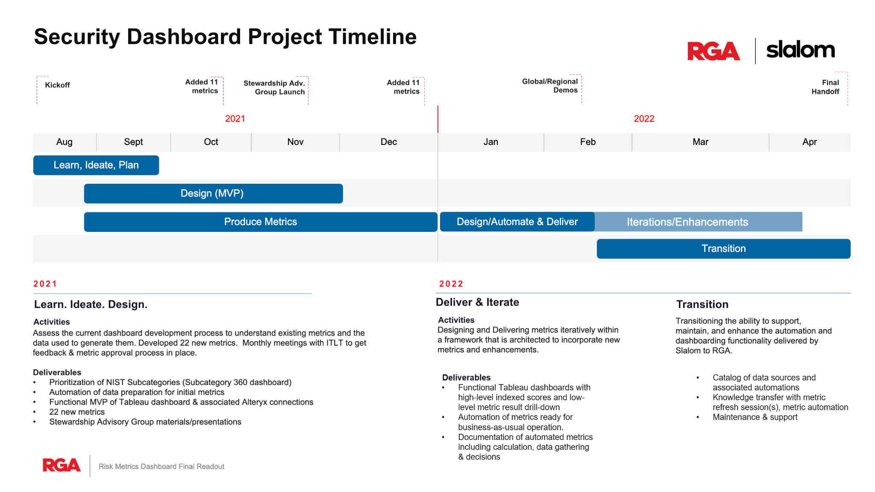

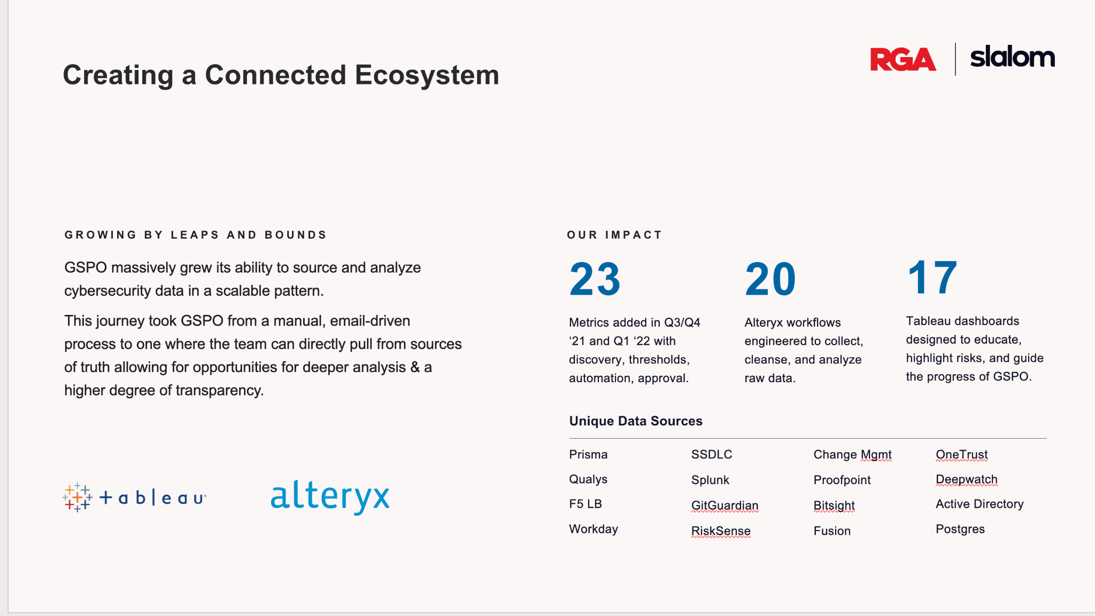

GSPO massively grew its ability to source and analyze cybersecurity data in a scalable pattern.​

This journey took GSPO from a manual, email-driven process to one where the team can directly pull from sources of truth allowing for opportunities for deeper analysis & a higher degree of transparency.​

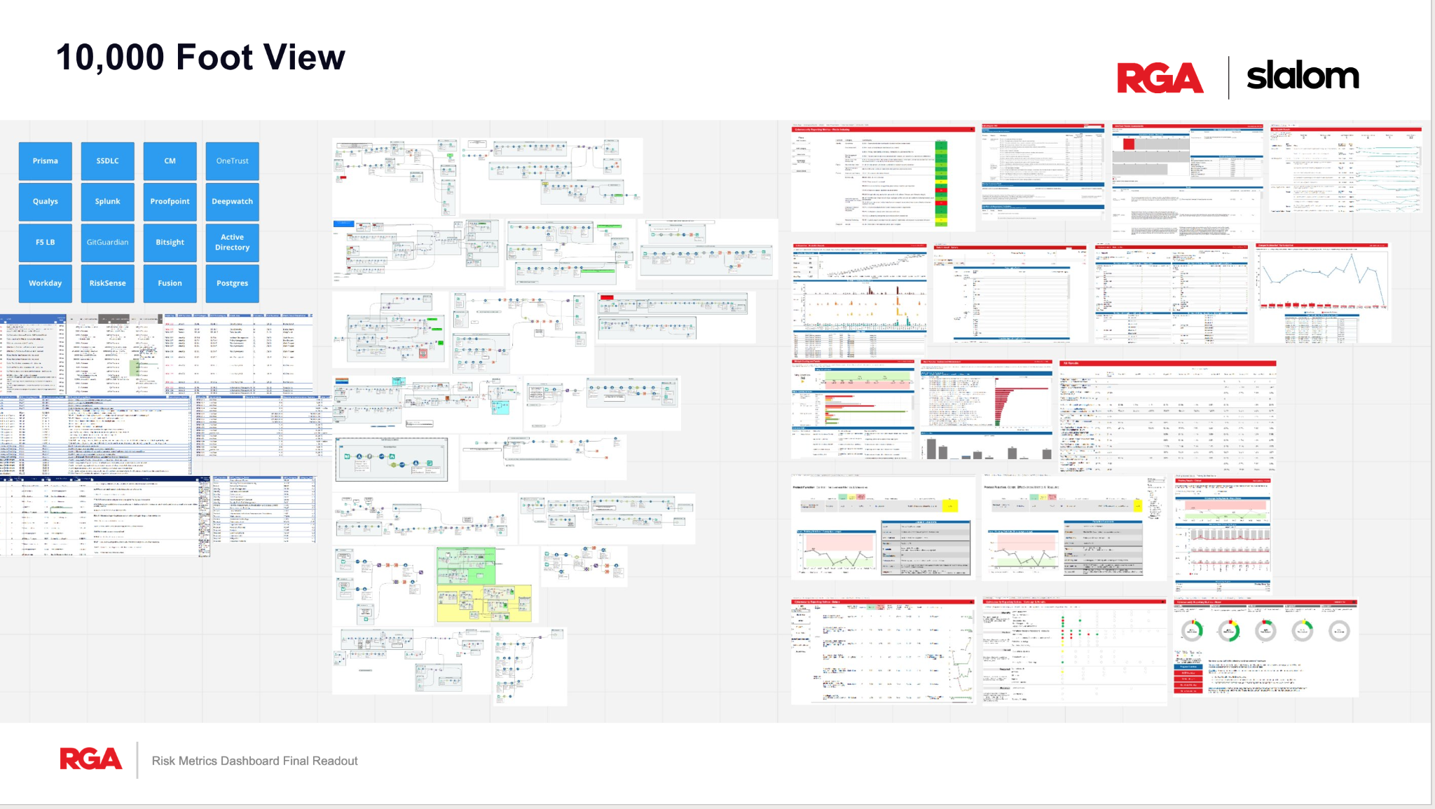





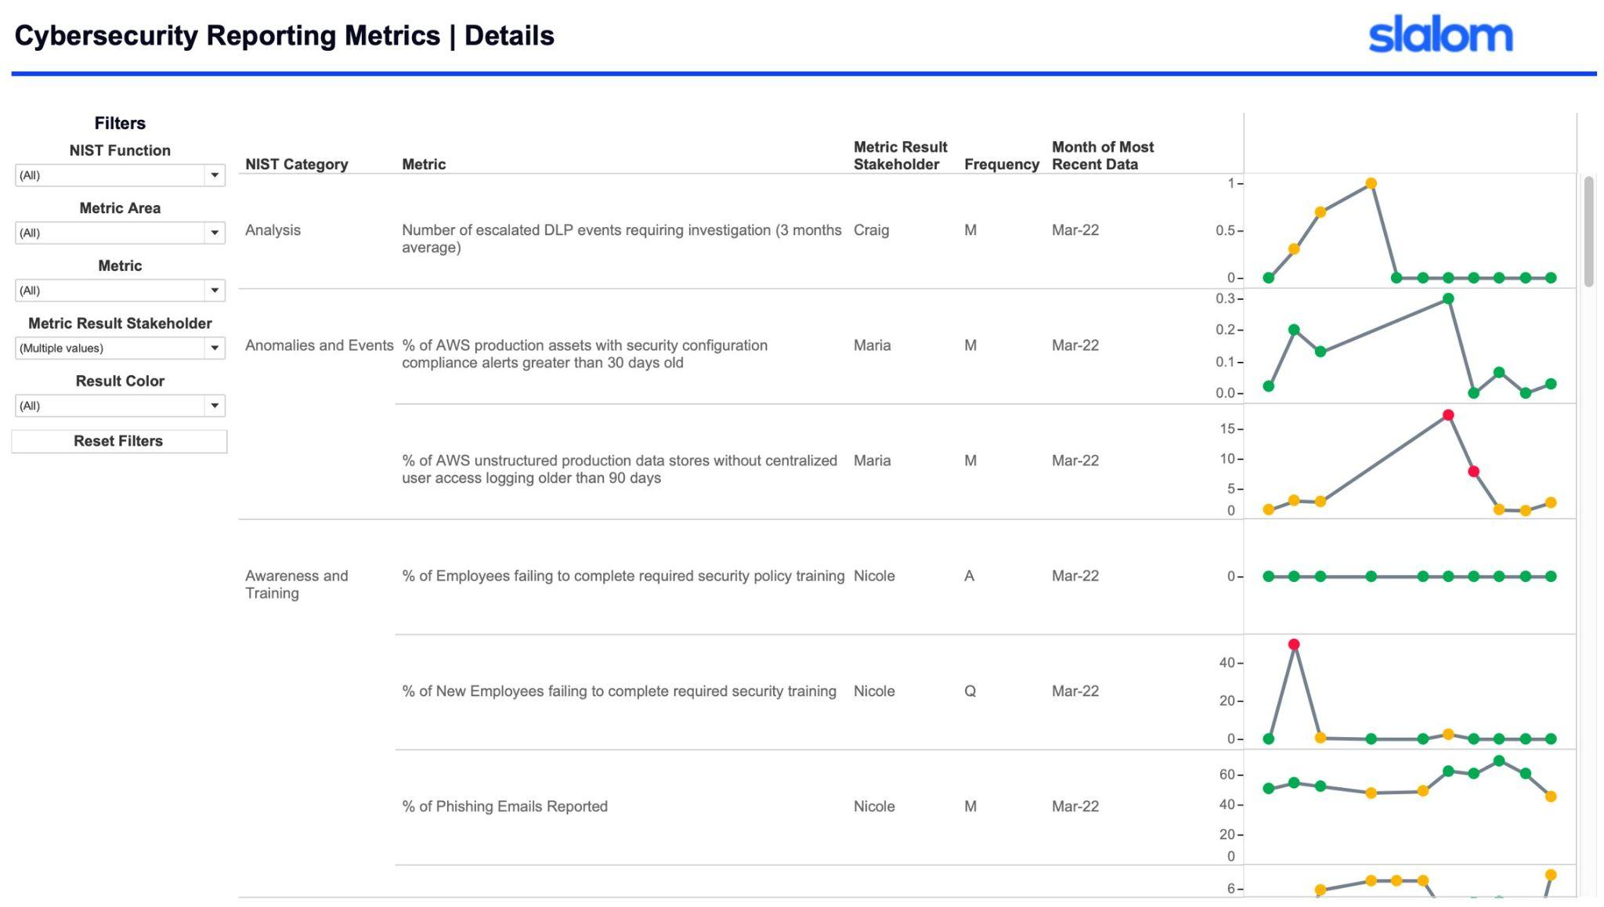

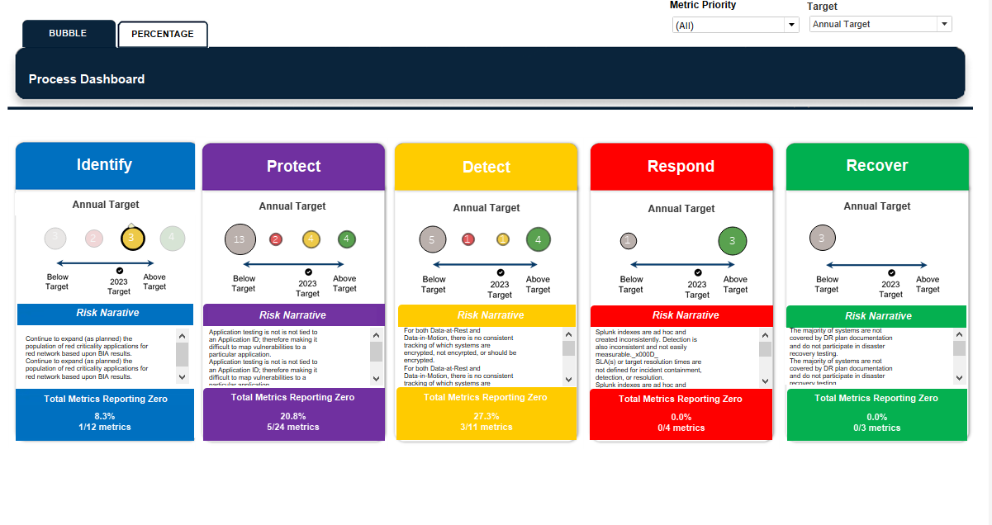

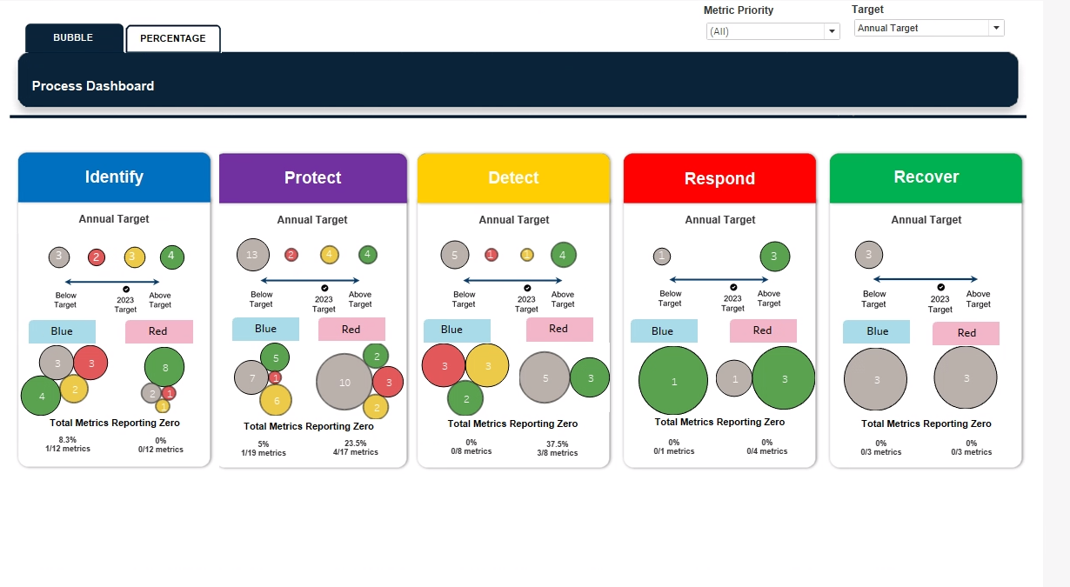

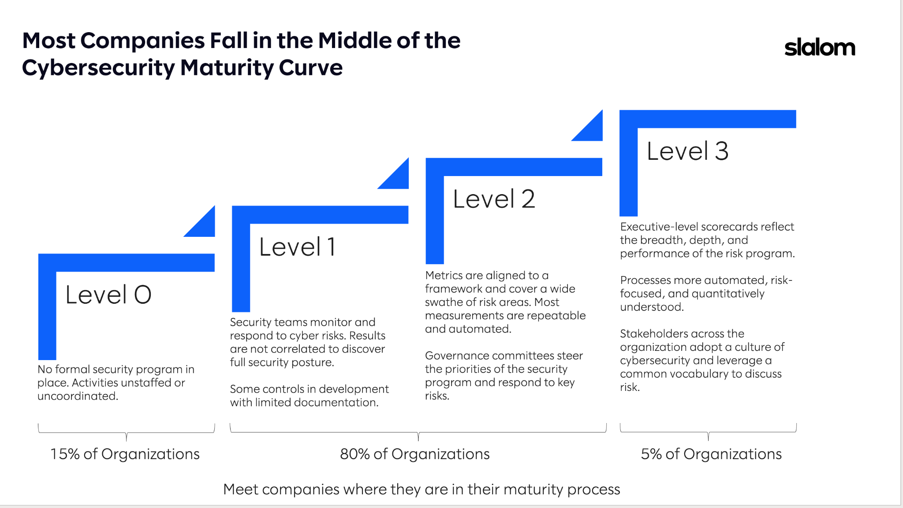

PWC, triple the cost. 5 person team.

Three bullet points value proposition

* Wealth of experience
* Technical skills
* Management/leadership
* A wealth of experience from 5 years of consulting
* Self-starting BI expert who can go from end-to-end
* Brings the razzle dazzle
* Undefeated technical problem solver
* Best demo in town
* Award-winning expert and thought leader in Tableau, Alteryx, and SQL with hands-on experience in dozens of other analytics and data engineering tools
* By combining successful relationship-building, innovative problem-solving, and open communication, can seamlessly carry a project from problem to solution with a keen eye for deriving true value from data
* Invaluable experience and best practices gained from five years working alongside the best D&A practitioners and clients in the region on every type of data project imaginable
* **Stellar communicator with the ability to distill complex thoughts and strategies into simple, impactful recommendations**

From problem to solution can collate multiple points of view, present options, and demo the pants off that thang

Relationship building

• Experience managing data strategy and leading team of data analysts preferred.

• 7+ years of work experience delivering BI analytics and data solutions, ideally within – or supporting – a finance organization

• Ability to manipulate data, gain insights from large datasets and **tell data stories**

• **Automate processes and analytics with technology. Tools that enable automation include, Alteryx, UiPath, Power BI, SQL, Tableau etc.**

• Ability to effectively manage and deliver on many projects at once within strict deadlines

• Some degree of ability and experience with Python or similar scripting language is a plus

• **Natural problem solver: comfortable with data and ambiguity; able to both delve into the details and operational tactics, and engage on the big picture or overall strategy**

• Proactive and passionate about results and data integrity

•  **Capable of independently seeking out information, solving conceptual problems, corralling resources and delivering results in complex situations**

• Ability to act with limited oversight on a day-to-day basis, balancing multiple priorities

• Ability to adapt and someone who is excited by working in a constantly evolving team

**• Stellar communication skills with the ability to distill complex thoughts and strategies into simple, impactful recommendations**

• Strong financial experience, understanding financial systems, General Ledgers, Sub-Ledgers, EPM tool and other related applications

POST-INTERVIEW

Realizing that they need to mature their D&A strategy

Need a teacher

Need to roll out reporting/dashboarding to regional leaders, etc.

ThoughtSpot

Do not have project planning / agile

Drive towards self service. End firefighting. Build for most important stakeholders first.

